Description of the Product

3 HP ELECTRIC OUTBOARD MOTOR
SEAGÖ SE3XX is an electric outboard motor has a rated voltage of 48V, and the maximum power is 2.2 kW. Compared to the existing gasoline models, the electric outboard is quieter and more environmentally friendly because they run on electricity instead of fuel. Additionally, we use Permanent Magnet Synchronous Motors, which have reduced noise, extended lifespan, increased efficiency and require less maintenance.
Relevant Boat Class
Small vessels of various materials including inflatable boats, wooden boats, FRP boats, plastic boats and similar, with lengths ranging from 2 to 4 Metres, are a good fit for the electric 3-horsepower outboard motor.
Recommended Battery
For this Model, 48V 50 AH LiFePO4 – Lithium Ferrous Phosphate battery packs can be utilized
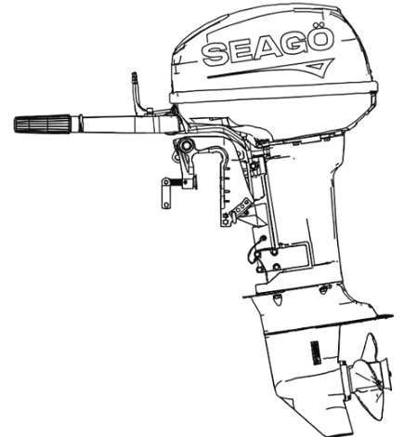
Model Options
SE3XX - Tiller Control

Specifications

Product Model | SE3XX
Rated Power | 2.2 kW
Rated Voltage | 48 V
Motor Type | Magnetic Synchronous Motor
Sensor Type | Magnetic Encoder
Steering System | Tiller Control
Maximum Speed | 4500 - 5000 RPM
Gear Ratio | 2.08
Transom Height | 417mm
Weight {Kg} | 13.5 Kg
Cooling System | Air Cooled
Gear Position | Forward

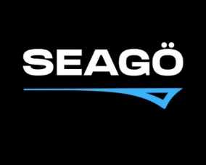
www.seago.in sales@seago.in +91-8606366633
3 HP ELECTRIC OUTBOARD MOTOR

